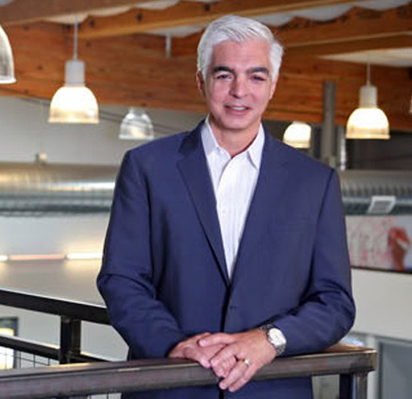
Charlie Muttillo
President
Morley Builders

Having begun his career at Morley over 30 years ago, Charlie Muttillo now serves as President. Today, his sights are set on a Morley future ripe with innovation and sustainable growth. But despite the promise of tomorrow, it remains paramount to Charlie that the company never waivers from its founding principles. He credits Morley’s founders and their core beliefs for making Morley the construction company to which California businesses, developers and public institutions can turn for buildings of enduring value and for builders of enduring integrity. Of course, he’s proud of Morley’s projects, but according to Charlie, it’s the caring, commitment and charisma of the company’s employee-owners and tradesmen that have made it all possible. He sees the coming years as being marked by new business relationships, new technical accomplishments, even more noteworthy projects, more robust communications and enduring financial success. Charlie lectures at UCLA Extension’s Construction Management Program and serves as Vice Chair for Santa Monica’s Building & Safety Commission. He serves as a board member for Affordable Living for the Aging and formerly was President of USC’s Architectural Guild and the Downtown Breakfast Club.

Charlie has a B.S. in Construction Management, California Polytechnic State University, San Luis Obispo, and completed the Anderson Graduate School of Management Executive Program at UCLA

“Instead of coasting on prior accomplishments, we’re going to continue to invest in quality relationships, quality projects and the highest quality talent, those who are inspired by the values of integrity, collaboration and innovation.”

