## 

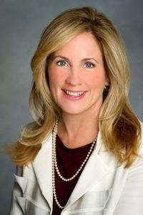

**Kathy Mandato  
Executive Vice President, Human Resources  
NBC Entertainment**

**Kathy Mandato** is Executive Vice President, Human Resources, NBC Entertainment, servicing primetime, late night, and alternative programming for NBC and Universal Television Studio. She reports to Robert Greenblatt, Chairman, NBC Entertainment. Mandato also oversees HR Shared Services for NBCUniversal.

Prior to NBC, Mandato served as Senior Vice President, Human Resources, for the Comcast Entertainment Group (CEG), a programming division of Comcast Corporation comprised of E! Entertainment Television, Style, G4, Comcast International Media Group, and E! Online.

She began her career in advertising in account management and business development with agencies including BBDO Worldwide where she served as Vice President, New Business Development and Communications for its Los Angeles, San Francisco, and Atlanta offices.

After 10 years in advertising, Mandato changed careers and entered the human resources field at Turner Broadcasting in Atlanta, managing recruitment, development, and diversity for Turner Entertainment Networks including serving as its EEOC Officer.

She later returned to Los Angeles, where she served as Director, Executive Recruitment and Human Resources, at E! Entertainment Television and later, Vice President, Human Resources for the Southwest Region of marchFIRST, an international internet consulting company.

In 2001, Mandato became the Head of Human Resources for DreamWorks SKG and was part of the team that took the animation division public in 2004. She then served as Head of Human Resources for DreamWorks Animation for three years before joining Comcast and E! Entertainment again in 2007.

Today, Mandato is very active with several LA based organizations that assist underserved youth and currently serves on the board of My Friend's Place, a non-profit organization for at-risk and homeless youth.

Mandato received her B.S. degree in journalism and mass communications with a minor in public relations from Kansas State University. She lives in Studio City with her husband and two daughters.