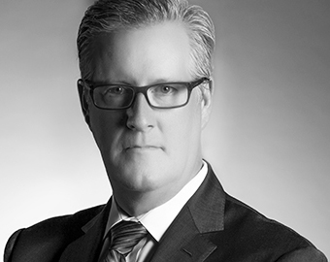
William Nelson
EVP Human Resources
Westfield

William Nelson joined Westfield LLC in 2011 and is responsible for providing leadership, direction, and prioritization to the US Westfield Human Resources organization.

Prior to joining Westfield, he held a variety of executive level human resource roles in diverse industries, living and working in countries across Asia, Australia, Canada, Europe, and the United States.

He holds bachelors and Masters of Science degrees from Loyola University of Chicago and an MBA from Rochester Institute of Technology.

